Disaster Management System
By Remotz Systems

Deliverable-3

Project Team

Muhammad Moiz Ansari 23i-0523
Zohaib Umer 23i-0528
Rehan Tajik 23i-0730
Muhammad Tayyab 23i-0738

Semester 6

Supervised by
Ms. Rabail Zahid



Department of Computer Science National University of Computer and Emerging Sciences Islamabad, Pakistan
April 19th, 2026

PART B — Development Methodology (Scrum) - Sprint 3

1. Sprint Backlog for Sprint 3
1.1 Sprint Duration: March 31, 2026 - April 18, 2026 (2.75 weeks)
1.2 Sprint Goal: Complete the disaster response coordination setup by implementing NGO/Rescue Team assignment, real-time mission tracking, status management, report generation, and feedback collection, delivering the fully integrated Disaster Management System.
1.3 Modules Developed in Sprint 3: Coordination, Monitoring & System Completion
- Assign NGO (US-19 to US-21)
- Assign Rescue Team (US-22 to US-24)
- Track Rescue Team (US-25 to US-27)
- Update Mission Status (US-28 to US-30)
- Generate Disaster Report (US-31 to US-33)
- Give Feedback & Review Feedback (US-34, US-35)
2. Sprint Backlog for Sprint 3
2.1 Module Name
Coordination, Monitoring & System Completion

2.2 User Stories
User Story 19:
Story ID: US-19 | Story Title: Assign NGO
User Story |  | Importance:
As an Admin, I want to assign NGOs to disaster-affected locations so that I can dispatch an appropriate NGO efficiently. |  | High
 |  | Estimate:
 |  | 3 day
Acceptance Criteria |  | Type:
- The system provides options to track the availability of NGOs  - System validates that only available NGOs are assigned.  - If an unavailable NGO is assigned, the system shows an error message.  - System updates the NGO database after confirmation.  - System logs all NGO assignment actions. |  | ☐ Search  ■ Workflow  ☐ Manage Data  ☐ Payment  ☐ Report / View

User Story 20:
Story ID: US-20 | Story Title: View Available NGOs
User Story |  | Importance:
As an Admin, I want to be able to view all available NGOs so I can make decisions on which NGO is to be assigned to a specific mission. |  | Medium
 |  | Estimate:
 |  | 1 day
Acceptance Criteria |  | Type:
- The system provides a tabular display listing NGOs, their information(location, personnel, speciality) and availability.  - The system updates the status of availability as soon as the NGO is assigned. |  | ☐ Search  ☐ Workflow  ☐ Manage Data  ☐ Payment  ■ Report / View

User Story 21:
Story ID: US-21 | Story Title: Assign Rescue Team
User Story |  | Importance:
As an Admin, I want to assign Rescue Teams to disaster-affected locations so that I can dispatch an appropriate Rescue Team efficiently. |  | High
 |  | Estimate:
 |  | 3 day
Acceptance Criteria |  | Type:
- The system provides options to track the availability of Rescue Teams  - System validates that only available Rescue Teams are assigned.  - If an unavailable Rescue Team is assigned, the system shows an error message.  - System updates the Rescue Team database after confirmation.  - System logs all Rescue Team assignment actions. |  | ☐ Search  ■ Workflow  ☐ Manage Data  ☐ Payment  ☐ Report / View

User Story 23:

Story ID: US-23 | Story Title: View Available Rescue Teams
User Story |  | Importance:
As an Admin, I want to view available rescue teams so that I can select the most suitable team for disaster response. |  | Medium
 |  | Estimate:
 |  | 2 days
Acceptance Criteria |  | Type:
- System displays a list of all rescue teams.  - System shows team details (location, availability, specialization).  - System filters only available teams.  - If no teams are available, system shows an appropriate message.  - Data is retrieved in real-time. |  | ☐ Search  ☐ Workflow  ☐ Manage Data  ☐ Payment  ■ Report / View

User Story 24:

Story ID: US-24 | Story Title: Assign Team to Disaster
User Story |  | Importance:
As an Admin, I want to assign a rescue team to a disaster so that rescue operations can start quickly and efficiently. |  | High
 |  | Estimate:
 |  | 3 days
Acceptance Criteria |  | Type:
- System displays disasters requiring rescue teams.  - System shows available rescue teams.  - Admin selects a team for a disaster.  - System validates availability of selected team.  - Upon confirmation, system assigns the team.  - System notifies the rescue team.  - System updates disaster and team status. |  | ☐ Search  ■ Workflow  ■ Manage Data  ☐ Payment  ☐ Report / View

User Story 25:

Story ID: US-25 | Story Title: Track Rescue Team
User Story |  | Importance:
As an Admin, I want to track rescue teams so that I can monitor their progress and ensure timely response. |  | High
 |  | Estimate:
 |  | 4 days
Acceptance Criteria |  | Type:
- System provides tracking option for rescue teams.  - System retrieves real-time team data.  - Admin can select a specific team to track.  - System displays current mission details.  - If team is offline, system shows alert message. |  | ☐ Search  ☐ Workflow  ☐ Manage Data  ☐ Payment  ■ Report / View

User Story 26:

Story ID: US-26 | Story Title: View Active Teams Dashboard
User Story |  | Importance:
As an Admin, I want to view an active teams dashboard so that I can get an overview of all ongoing rescue operations. |  | Medium
 |  | Estimate:
 |  | 2 days
Acceptance Criteria |  | Type:
- System displays all active rescue teams.  - Dashboard shows assigned disasters and status.  - Data updates in real-time.  - If no teams are active, system displays a message. |  | ☐ Search  ☐ Workflow  ☐ Manage Data  ☐ Payment  ■ Report / View

User Story 27:

Story ID: US-27 | Story Title:View Team Location & Status
User Story |  | Importance:
As an Admin, I want to view team location and status so that I can monitor progress and coordinate effectively. |  | High
 |  | Estimate:
 |  | 2 days
Acceptance Criteria |  | Type:
- System shows real-time location of selected team.  - System displays mission status (assigned, in progress, completed).  - System updates data dynamically.  - If location is unavailable, system shows an alert. |  | ☐ Search  ☐ Workflow  ☐ Manage Data  ☐ Payment  ■ Report / View

User Story 28:

Story ID: US-28 | Story Title: Update Mission Status
User Story |  | Importance:
As an NGO or Rescue Team member, I want to update mission status so that the admin stays informed about progress. |  | High
 |  | Estimate:
 |  | 3 days
Acceptance Criteria |  | Type:
- System allows NGO/Rescue Team to update mission status.  - System provides status options (In Progress, Completed).  - System validates the update.  - System records changes in database.  - System notifies admin of updates. |  | ☐ Search  ■ Workflow  ■ Manage Data  ☐ Payment  ☐ Report / View

User Story 29:

Story ID: US-29 | Story Title: Mark Mission In Progress
User Story |  | Importance:
As an Admin, I want to view available rescue teams so that I can select the most suitable team for disaster response. |  | Medium
 |  | Estimate:
 |  | 1 days
Acceptance Criteria |  | Type:
- System allows selection of assigned mission.  - User selects “In Progress” status.  - System validates the action.  - System updates mission status in database.  - Admin is notified of the update. |  | ☐ Search  ■ Workflow  ☐ Manage Data  ☐ Payment  ☐ Report / View

User Story 30:

Story ID: US-30 | Story Title: Mark Mission Completed
User Story |  | Importance:
As an Admin, I want to view available rescue teams so that I can select the most suitable team for disaster response. |  | Medium
 |  | Estimate:
 |  | 1 days
Acceptance Criteria |  | Type:
- System allows selection of assigned mission.  - User selects “Completed” status.  - System validates completion.  - System updates mission status in database.  - Admin is notified of completion.  - System logs mission completion. |  | ☐ Search  ■ Workflow  ☐ Manage Data  ☐ Payment  ☐ Report / View

User Story: 31

Story ID: US-31 | Story Title: Generate Disaster Report
User Story |  | Importance:
As an Admin, I want to generate detailed reports so that I can review disaster impact, resources used, and team efficiency. |  | High
 |  | Estimate:
 |  | 34 days
Acceptance Criteria |  | Type:
- The system must compile disaster events, affected areas, response teams, relief resources distributed, and outcomes.  - The system must log the report generation action for auditing purposes.  - If report generation fails due to a system error, the admin must be prompted to retry. |  | ☐ Search  ☐ Workflow  ☐ Manage Data  ☐ Payment  ■ Report / View

User Story 32:

Story ID: US-32 | Story Title: Set Report Parameters
User Story |  | Importance:
As an admin, I want to set specific parameters for the report so that the system can organize disaster data matching my criteria. |  | Medium
 |  | Estimate:
 |  | 3 days
Acceptance Criteria |  | Type:
- System must prompt the admin for report parameters like date, disaster type, region, and teams involved.  - Admin must be able to set desired parameters for the report into the system.  - If no disaster match the entered parameters, the system must display the exact message: "No disaster data found for selected parameters". |  | ☐ Search  ☐ Workflow  ■ Manage Data  ☐ Payment  ☐ Report / View

User Story 33:

Story ID: US-33 | Story Title: Export/Download Report
User Story |  | Importance:
As an Admin, I want to select a report format so that I can view or download the generated report. |  | Medium
 |  | Estimate:
 |  | 2 days
Acceptance Criteria |  | Type:
- System must prompt the admin to request a specific report format.  - System must successfully generate the report in the chosen format, supporting options like PDF or Excel.  - Admin must be able to view or download the report |  | ☐ Search  ☐ Workflow  ☐ Manage Data  ☐ Payment  ■ Report / View

User Story 34:

Story ID: US-34 | Story Title: Give Feedback
User Story |  | Importance:
As a citizen, NGO, or rescue team member, I want to share experiences or feedback for the system's performance so that the system could be improved. |  | Low
 |  | Estimate:
 |  | 2 days
Acceptance Criteria |  | Type:
- System must provide a feedback form once the authenticated actor selects the option to give feedback.  - If the feedback form is incomplete, the user must be prompted to fill in the mandatory fields.  - If a database error occurs during submission, the system must show a failure message. |  | ☐ Search  ■ Workflow  ☐ Manage Data  ☐ Payment  ☐ Report / View

User Story 35:

Story ID: US-35 | Story Title: Review Feedback
User Story |  | Importance:
As an admin, I want to view the submitted feedback so that I can review the feedback for the system's performance. |  | Low
 |  | Estimate:
 |  | 2 days
Acceptance Criteria |  | Type:
- System must store all recorded feedback properly.  - All recorded feedback must be accessible for review by the admin through the interface. |  | ☐ Search  ☐ Workflow  ☐ Manage Data  ☐ Payment  ■ Report / View

2.3 Structured Specifications
Specification 9-US-19: Assign NGO, Rescue Team
Field | Details
Use Case Name | Assign NGO / Assign Rescue Team
Actor(s) | Admin
Inputs | - Admin selects an option to assign a team or NGO.  - Selects a specific disaster.  - Selects a relevant and available rescue team or NGO for the assignment.
Outputs | - System displays lists of disasters requiring assistance.  - Shows available NGOs/Rescue Teams.  - Notifies the assigned entity.
Processing | - System filters available teams based on location, availability, and skill  - Filters NGOs based on relevance and availability  - Assigns the team and updates disaster records and team status upon acknowledgement.
Preconditions | - Disaster events exist in the system  - NGOs and rescue teams are registered and available.
Postconditions | - NGO or Rescue Team is assigned to the disaster incident  - The assigned entity acknowledges the assignment.
Exceptions | - If no entities are available, the system alerts the admin  - If admin cancels, the assignment is discarded  - Admin can reschedule or reassign if the first rescue team cannot respond.

Specification 10-US-25: Track Rescue Team
Field | Details
Use Case Name | Track Rescue Team
Actor(s) | Admin
Inputs | - Admin selects options to track rescue teams  - Selects a specific rescue team.
Outputs | - System retrieves a list of all active rescue teams and their assignments  - Displays the team's current location, disaster assignment, status, and estimated arrival time.
Processing | System updates real-time location and status based on inputs from the rescue team.
Preconditions | - Rescue teams are registered in the system  - Teams are assigned to at least one disaster.
Postconditions | Admin successfully views the real-time status of rescue teams.
Exceptions | - If a rescue team is offline/unreachable, the system alerts the admin  - If no teams are active, the system displays "No active rescue teams currently".

Specification 11-US-31: Generate Disaster Report
Field | Details
Use Case Name | Generate Disaster Report
Actor(s) | Admin
Inputs | - Admin selects option to generate disaster reports  - Enters report parameters (date, disaster type, region, teams involved)  - Requests report format.
Outputs | - System prompts for parameters  - Generates reports in the chosen format  - Displays or downloads the report.
Processing | - System compiles disaster events, affected areas, response teams, relief resources distributed, and outcomes  - Logs report generation for auditing purposes.
Preconditions | Disaster events, rescue assignments, and resource records exist in the system.
Postconditions | Admin successfully generates and views/downloads the disaster reports.
Exceptions | - If no disasters match the parameters, the system displays "No disaster data found for selected criteria."  - If report generation fails due to system error, admin is prompted to retry.

Specification 12-US-34: Give Feedback
Field | Details
Use Case Name | Give Feedback
Actor(s) | Citizen, NGO, Rescue Team
Inputs | - Actor selects the option to give feedback  - Actor enters feedback into the provided form.
Outputs | System provides a feedback form.
Processing | - System records the submitted feedback  - Admins can later review the feedback.
Preconditions | The actor is authenticated.
Postconditions | - Feedback is recorded  - Respective feedback is accessible to admin, NGO, rescue teams.
Exceptions | - If the feedback form is incomplete, the user is prompted to fill mandatory fields  - If a database error occurs, the system shows a failure message.

3. Scrum Board (Trello Snapshots)
3.1 Snapshot 1 - Initial Backlog Upload
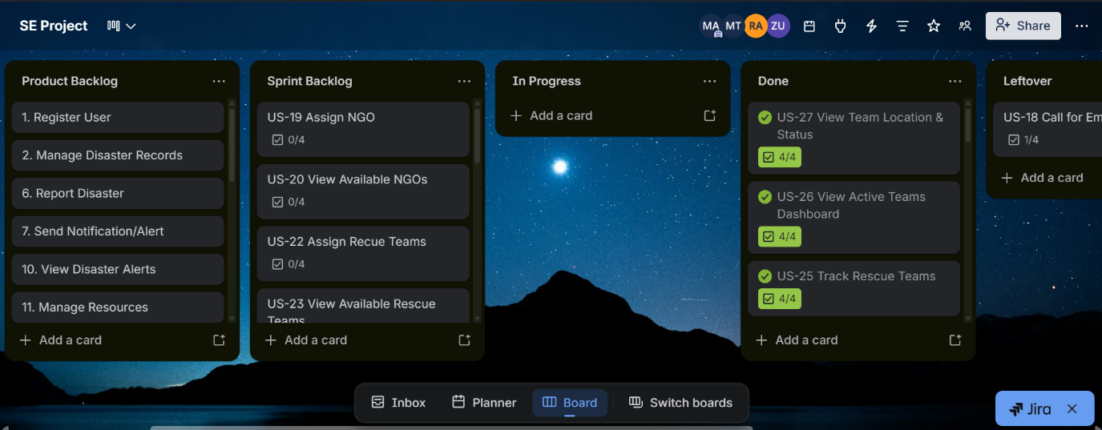

3.2 Snapshot 2 - Mid-Sprint Progress
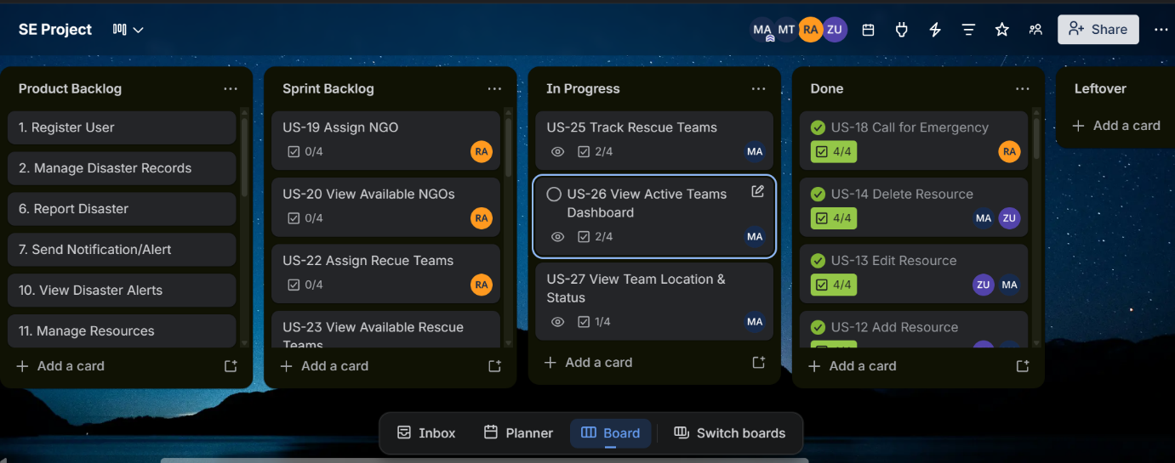

3.3 Snapshot 3 - End of Sprint
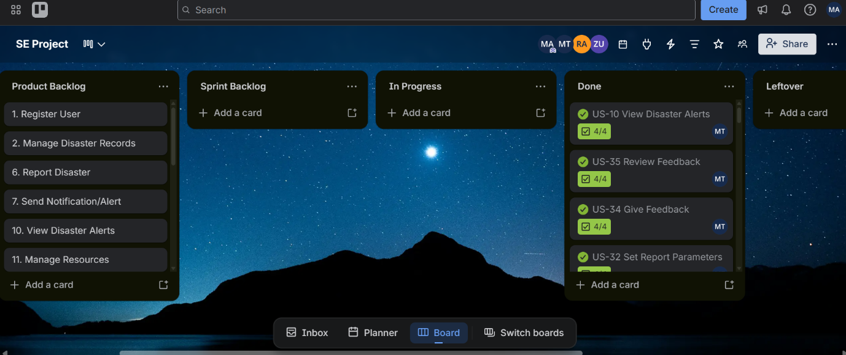

4. Product Burn-Down Chart - Sprint 3

5. Testing Activities - Sprint 3
5.1. Software Test Plan
Test Plan Title | Sprint 3 Software Test Plan — Disaster Management System
Version | 1.0
Prepared By | Remozone Systems — Muhammad Moiz Ansari, Rehan Tajik, Zohaib Umer, Muhammad Tayyab
Sprint | Sprint 3 — Coordination, Monitoring & System Completion
Test Period | April 1, 2026 – April 18, 2026
Scope | This test plan covers all Sprint 3 modules:  • Assign NGO (US-19 to US-21)  • Assign Rescue Team (US-22 to US-24)  • Track Rescue Team (US-25 to US-27)  • Update Mission Status (US-28 to US-30)  • Generate Disaster Report (US-31 to US-33)  • Give & Review Feedback (US-34, US-35)
Test Objectives | 1. Verify that NGO and Rescue Team assignment correctly updates all related database records.  2. Verify that mission status transitions are enforced and reflected in real time.  3. Verify that report generation produces correct data for all filter combinations.  4. Verify that feedback submission and review workflows function correctly.  5. Verify that all exception paths display appropriate error messages without crashing.
Test Types | • Functional Testing — each use case against its acceptance criteria  • Black-Box Testing — equivalence partitioning and boundary value analysis  • White-Box Testing — statement, branch, and condition coverage on critical methods  • Regression Testing — ensure Sprint 1 & Sprint 2 features remain unaffected
Tools & Environment | IDE: IntelliJ IDEA / Java 17  Database: SQL Server Express (local)  Manual testing via JavaFX UI  Test evidence: screenshots and console output logs
Entry Criteria | • Sprint 3 features are fully coded and compiled without errors.  • Database schema matches the expected Sprint 3 design.  • Sprint 1 & 2 features pass regression checks.
Exit Criteria | • All critical and high-priority test cases pass.  • No open Critical or High severity defects remain unfixed.  • All modules produce correct outputs for valid inputs.  • Exception paths display user-friendly error messages.

5.2. Black-Box Test Cases
Techniques used: Equivalence Partitioning (EP), Boundary Value Analysis (BVA), Error Guessing (EG)

TC-ID | Feature / Use Case | Input(s) | Expected Output | Technique | Result
TC-01 | Assign NGO | Valid: Active disaster + Available NGO selected | NGO assigned; disaster record updated; success message | Equivalence Partitioning | Pass
TC-02 | Assign NGO | Invalid: No NGOs available in system | Alert: 'No NGOs currently available.' Assignment blocked | Error Guessing | Pass
TC-03 | Assign NGO | Invalid: Disaster already has NGO assigned | System prevents duplicate assignment | Equivalence Partitioning | Pass
TC-04 | Assign Rescue Team | Valid: Active disaster + Available team selected | Team assigned; Mission record created; team status = Deployed | Equivalence Partitioning | Pass
TC-05 | Assign Rescue Team | Invalid: Selected team has status 'Deployed' | Team card greyed out; cannot be selected | Equivalence Partitioning | Pass
TC-06 | Track Rescue Team | Valid: Active missions exist in system | Teams list populated with correct status badges and ETAs | Equivalence Partitioning | Pass
TC-07 | Track Rescue Team | Edge: No active missions | Empty state displayed: 'No active rescue teams currently.' | Boundary Value Analysis | Pass
TC-08 | Update Mission Status | Valid: Change status from Assigned → On Site | Status updated in DB; timeline entry added; Admin dashboard refreshed | Equivalence Partitioning | Pass
TC-09 | Update Mission Status | Edge: Status already Completed — attempt to change | System prevents change; status options for completed missions are disabled | Error Guessing | Pass
TC-10 | Generate Report | Valid: Date range Jan 1 – Dec 31, All types, All severities | Report generated with correct totals; export buttons enabled | Equivalence Partitioning | Pass
TC-11 | Generate Report | Invalid: Start date > End date | Error shown: 'Invalid date range.' Generation blocked | Boundary Value Analysis | Pass
TC-12 | Generate Report | Edge: No disasters match the filter criteria | 'No disaster data found for selected criteria.' Preview shows zeros | Boundary Value Analysis | Pass
TC-13 | Give Feedback | Valid: All fields filled, 4-star rating, non-anonymous | Feedback saved with status 'Pending'; confirmation shown | Equivalence Partitioning | Pass
TC-14 | Give Feedback | Invalid: Rating not selected (0 stars) | Validation error: 'Please rate your experience (1–5 stars).' | Boundary Value Analysis | Pass
TC-15 | Give Feedback | Invalid: Feedback type = NGO Service but no entity selected | Validation error: 'Please select a specific NGO for this feedback type.' | Error Guessing | Pass
TC-16 | Give Feedback | Invalid: Non-anonymous but email field left empty | Validation error: 'Please enter your email address.' | Equivalence Partitioning | Pass
TC-17 | Review Feedback | Valid: Admin marks feedback as Resolved | Feedback status updated; counter updated on Admin dashboard | Equivalence Partitioning | Pass
TC-18 | Review Feedback | Valid: Admin searches for feedback by keyword | Filtered list shows only matching feedback cards | Equivalence Partitioning | Pass

5.3. White-Box Testing
Method Under Test | performAssignment() — AssignRescueTeamController
Description | Assigns a rescue team to a disaster, creates a Mission, and updates team/disaster status.
Coverage Criteria | Branch Coverage
Paths/Conditions Tested | Path 1 (Happy): teamUpdated=true AND disasterUpdated=true AND missionCreated=true → shows success, reloads data.  Path 2 (Team update fail): teamStatusUpdated=false → shows error, no mission created.  Path 3 (Disaster update fail): assignSuccess=false → shows error, rollback attempted.  Path 4 (Mission creation fail): missionCreated=false → partial success warning shown.
Coverage Result | 4 of 4 branches covered (100% branch coverage)

Method Under Test | validateForm() — GiveFeedbackController
Description | Validates all required fields before feedback submission.
Coverage Criteria | Condition Coverage
Paths/Conditions Tested | Condition 1: feedbackTypeCombo.getValue() == null → returns false, shows error.  Condition 2: Feedback type requires entity AND entityCombo = N/A → returns false.  Condition 3: currentRating == 0 → returns false, shows star rating error.  Condition 4: subjectField is empty → returns false.  Condition 5: feedbackArea is empty → returns false.  Condition 6: !anonymous AND email invalid → returns false.  Condition 7: All conditions pass → returns true, submission proceeds.
Coverage Result | 7 of 7 conditions tested (100% condition coverage)

Method Under Test | updatePreview() — GenerateReportController
Description | Fetches live data and updates the report preview panel based on selected filters.
Coverage Criteria | Statement Coverage
Paths/Conditions Tested | Statement 1: startDate or endDate is null → sets error title, resets labels, returns early.  Statement 2: startDate.isAfter(endDate) → same early return path as Statement 1.  Statement 3: Valid date range → fetches totals, updates all preview labels.  Statement 4: selectedSeverity != 'All Severities' → appends severity tag to preview title.  Statement 5: breakdown is empty → sets 'No disaster data found' in breakdown container.
Coverage Result | All 5 statement branches executed (100% statement coverage)

5.4. Bug Report Summary
Bug ID | Module | Severity | Description | Status | Fix Applied
BUG-01 | Assign Rescue Team | High | Mission ID generator duplicated IDs when multiple missions existed with non-sequential IDs (e.g., MIS001, MIS010 → generated MIS002 instead of MIS011). | Fixed | Replaced manual ID generator with DB query fetching MAX ID.
BUG-02 | Track Rescue Team | Medium | Map pin did not appear when team's city was not found in MAPLOCATION table; NullPointerException thrown. | Fixed | Added null check in updatePinPosition(); falls back to default map center coordinates.
BUG-03 | Manage Disasters | High | The status of rescue and ngo team didn’t update when the disaster was deleted. | Fixed | Added team id fetcher and updated teams’ statuses, if they were assigned to the respective disaster..
BUG-04 | Review Feedback | Low | The color of labels on feedback differed from the buttons of labels. | Fixed | Swapped the colors of labels.
BUG-05 | Review Feedback | Low | Average rating label on Admin Dashboard showed 'NaN/5.0' when no feedback existed in the database. | Fixed | Added null/NaN guard in loadFeedbackStats(); defaults to 0.0 when no ratings exist.

5.5. Test Results and Observations
Total test cases executed: 18
Passed: 18 | Failed: 0 | Blocked: 0

Key observations:
● All critical user flows (assign NGO, assign rescue team, mission status update) pass with correct database state transitions.
● Report generation correctly handles boundary cases such as equal start/end dates and empty result sets.
● Feedback validation correctly blocks submission for all identified invalid input combinations.
● Five bugs were identified during testing; all five were resolved before sprint completion.
● White-box analysis confirmed 100% branch, condition, and statement coverage on the three critical methods tested.

How testing improved system quality:
Testing in Sprint 3 specifically uncovered the Mission ID duplication bug, which could have caused data integrity failures in production. The null-pointer exception in the Track Rescue Teams map view was also caught before delivery, preventing a runtime crash. Systematic condition coverage of the feedback validator eliminated all edge-case submission bypasses. Overall, the test activities increased confidence in the correctness and robustness of the final integrated system.

